**Sample Preparation and Metallography Lab**

|  |  |
| --- | --- |
| Original Author: | Matthew Swenson |
| Application: | MS Word |
| File Name: | MEC 211 Research LSM 27-Aug-13.docx |

**REVISION HISTORY**

|  |  |  |
| --- | --- | --- |
| Rev. | Revision Description | Approved By: |
| 1.0 | As Issued | __________________________________ Dr. Janelle Wharry, PI date |
| __________________________________ Dick Sevier, COEN Safety Liaison date |
| __________________________________ Dr. Suzy Arnette, date EH&S Lab. Safety Officer |
|  |  |  |

**TABLE OF CONTENTS**

1.0 Scope 3

2.0 Shared Lab Spaces 3

3.0 Lab Safety Checklist 4

4.0 Lab Operations and Hazards 5

4.1 Description of Lab Operations 5

4.2 Hazards Summary 5

4.2.1 Chemical Hazards 5

Appendix A. Laboratory Evacuation 6

|  |  |
| --- | --- |
| Scope | This document is intended to provide safety information on the safety equipment, activities and hazards specific to the space(s) used by this lab.  This document is intended to be used in research labs in conjunction with the **COEN General Lab Safety Manual** and other lab safety training.  It is mandatory that all individuals who perform work in the lab be fully aware of this document’s existence, understand its contents, and satisfy the testing requirements associated with it. This burden of knowledge and training is the shared responsibility of the PI, lab supervisor and individual lab workers. |
| Shared Lab Spaces | Shared lab spaces require additional cooperation by lab owners to ensure a safe environment for all.  A lab-specific safety manual should be written for any space that is:   * shared by multiple PIs working independently   OR   * shared by co-PIs that do not share the same research team   This may require having multiple lab-specific safety manuals as needed based on the lab spaces used. |

|  |  |
| --- | --- |
| Lab Safety Checklist | Below is a checklist of important safety-related information for your lab space(s). **Familiarize yourself with this information. See Appendix A Laboratory Evacuation more information.**    **Lab Location: MEC 211**  Building Address: 1020 Manitou Ave.  Lab Phone Number: n/a  Important Safety-Related Locations:  Secondary Contact Info: Lab entrance  Lab Safety Notebook: Near exit of MEC 211  Nearest Fire Extinguisher: Near exit of MEC 211  Nearest First Aid Kit: MEC 211 (Drawer on North wall)  Nearest Eyewash/Safety Shower: Near exit of MEC 211  Nearest Chemical Spill Kit: MEC 211 (Near Hood, NE Corner)  Nearest AED: MEC 2nd floor opposite elevator  Nearest Fire Alarm Pull: At north & south stairwells, MEC 2nd floor  Nearest Phone: MEC 4th floor adjacent to elevator  Safe Assembly Area For Evacuation: Parking lot of ENGR Bldg.  Meet 1st Responders: On Manitou Ave. |

|  |  |
| --- | --- |
| Lab Operations and Hazards | |
| Description of Lab Operations | The operations and activities of this lab include the following:   * Cold Rolling * Polishing * High temperature furnace * Diamond Cutting * Pressing * Microscope * Etching * Engraving |
| Hazards Summary | The hazards of the lab’s operation(s) include the following:   * Chemical * Compressed Gas * Electrical * Mechanical * Flammable Gas/Liquid * Pressure or Vacuum * Thermal Energy * Pinch/Crush |
| Chemical Hazards | Chemical hazards must be described in the protocols that use them. Consult these protocols or your PI if you have questions.  Information on managing chemical spills and handling chemical waste can be found in the **COEN General Lab Safety Manual**.  Additional safety information and training on chemical hazards can be found on the Skillport training website. |

###### 

###### Laboratory Evacuation

**When ordered to evacuate or when alarms are activated, ALWAYS LEAVE IMMEDIATELY.**

* Unless ordered otherwise by officials, designated Building Coordinators and/or alternates and assistants (identified with red armbands) shall direct and ensure, to the extent practical, that a safe personnel evacuation is conducted. Treat all alarms as warning of an actual emergency situation.
* All department heads, faculty, managers and supervisors must help direct employees, students, visitors and each other to obey evacuation instructions of emergency response personnel and/or the Building Coordinators.
* Building Coordinators and/or alternates and assistants shall notify emergency personnel immediately upon their arrival at the scene concerning the status of the evacuation, the exact location of any injured or trapped persons, those waiting in designated Areas for Evacuation Assistance, any others who may be anywhere in the building, and any other relevant information on the emergency situation.

**Exit quickly and calmly using nearest emergency escape routes and marked exits and proceed to Safe Assembly Locations.  DO NOT USE ELEVATORS!**

* Do not attempt to use elevators during an emergency.  Elevators are called to the first floor when the fire alarm system is activated.  Use only stairways in an evacuation.
* Use clear, safe escape routes and exits and proceed to the nearest outside Safe Assembly Location shown on this building’s posted evacuation map, or to a location ordered by emergency response personnel.  Do not return to an evacuated building until directed by University officials.
* If possible, take your coat and keys but do not take time to go to lockers or offices for personal possessions.
* Where applicable and, if possible and safe, turn off laboratory gases, exhaust fans, and close doors/windows as you exit.

**Assist persons requiring evacuation assistance to get to designated Areas for Evacuation Assistance.  Be alert for trapped, injured, or other persons requiring assistance.**

* Transporting of individuals requiring evacuation assistance up or down stairwells shall be avoided until emergency response personnel have arrived.  Unless imminent life-threatening conditions exist, relocation of these individuals shall be limited to the designated Areas for Evacuation Assistance.
* Notify emergency personnel immediately upon their arrival of the exact location of any injured or trapped persons, those waiting in designated Areas for Evacuation Assistance, and any others who may be anywhere in the building.

Evacuation & Safety Equipment Map-

**Micron Engineering Center, 2nd Floor**

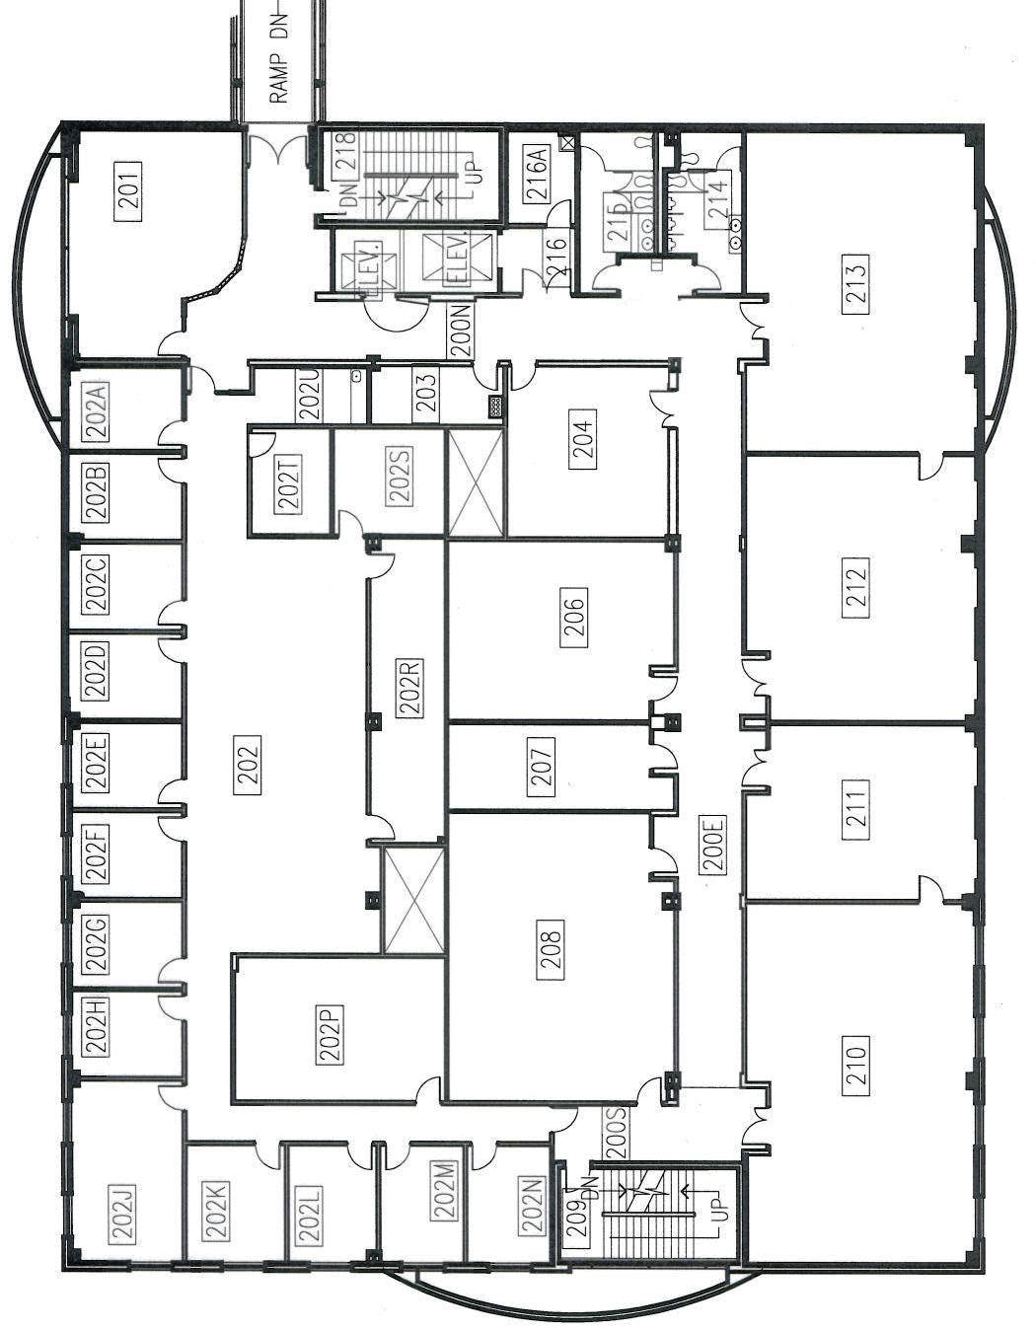

**Safe**

**Assembly**

**Location:**

**ENGR Building**

**Parking Lot**

**N**

**Fire Alarm Pull Station**

**Fire Extinguisher\***

**AED- MEC 2nd Floor, Opposite Elevator**

**Emergency Phone**

**Evacuation**

**Assistance Area**

* lab extinguishers  
 not shown.

